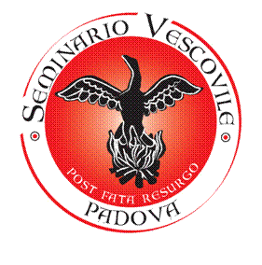
Biblioteca del Seminario Vescovile di Padova

Via del Seminario, 29 - 35122 Padova
Tel.: 049 2950835 Fax: 049 8761934
e-mail: infoibliotecaseminariopda.it

DIGITAL REPRODUCTIONS FOR COMMERCIAL PURPOSES

Applicant: ______________________________________________________________________
Address: _________________________________________________ tel. ________________
Email: ________________________________

Requests:

⁕ The digital reproduction of the following material:
Location: ___________________________________________________________________
Title: ______________________________________________________________________
Author: ____________________________________________________________________
Pages to be reproduced: ______________________________________________________
□ with personal equipment
□ via Library
□ via professional

⁕ Authorization for its publication in:
□ Book/periodical
Author: _____________________________________________________________________
Title: ______________________________________________________________________
Place and date of publication: _________________________________________________
Number of copies expected: ___________ Cover price: ___________________________
□ Website __________________________________________________________________
□ Other type of publication ___________________________________________________

Conditions and Rates

Cost of reproductions made by the Library:
a) Manuscripts and printed books: €0.50 per shot
b) Correspondence-Letters: €1.00 per shot
For full reproductions or reproductions exceeding 10 sheets (= 20 pages), a fee ranging from €20.00 to €50.00 will apply (depending on the item's value or rarity).

Reproduction rights cost per image:
Inside the publication: €50.00
Cover: €100.00

These amounts serve as reimbursement for document reproduction costs.

The Seminary Library does not issue invoices but provides a receipt (acknowledgment of payment), which must be expressly requested by the user when submitting the form to the Library.
If an invoice is needed, a professional photographer must be contacted.

Payment Details:
Seminario vescovile di Padova
Via del Seminario 29 – 35122 Padua – Italy
Tax Code: 80008630289
Bank details:
Bank: Banca Popolare di Verona
IBAN: IT88K0503412112000000000593
Purpose: Contribution for the library

The undersigned expressly declares under their own responsibility that the reproductions obtained will not be used for purposes other than those declared and that they will comply with current copyright regulations. The granted rights, non-exclusive and valid for one-time use only, are not transferable or assignable.
They also commit to:
- Provide the Library with 1 free copy of the publication
- Cite the Ancient Library of the Seminary of Padua for each published image, specifying its location in the collection.

Date:__________________________________
Signature:__________________________________

__________________________FOR LIBRARY USE ONLY__________________________
□ Authorized
□ Not authorized for the following reasons: ___

Library Director

__________________________________

